**Alekhya Krishna Balivada Pyspark Assessment 4 (26-12-2023)**

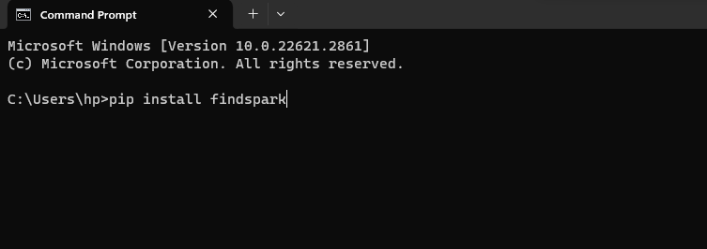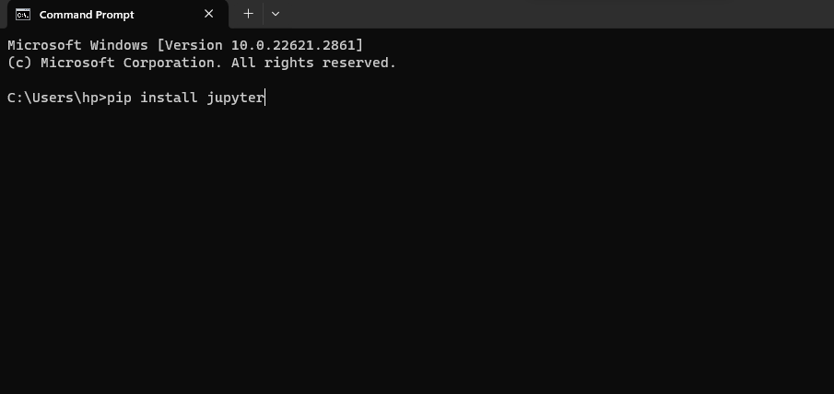**Installing Jupyter Installing findspark**

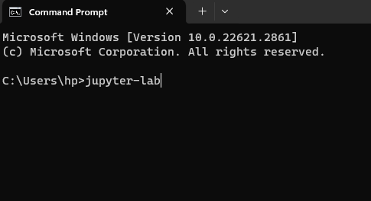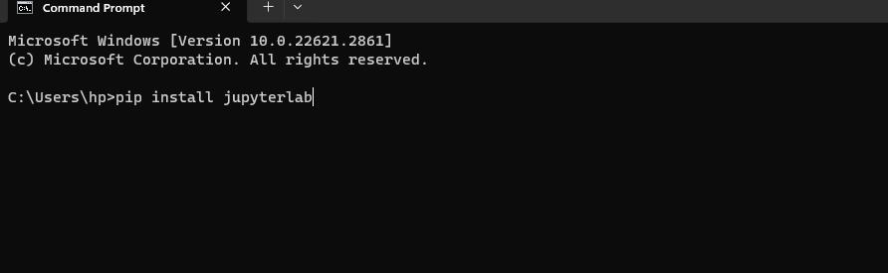**Installing Jupyter lab Opening Jupyter-lab on web**

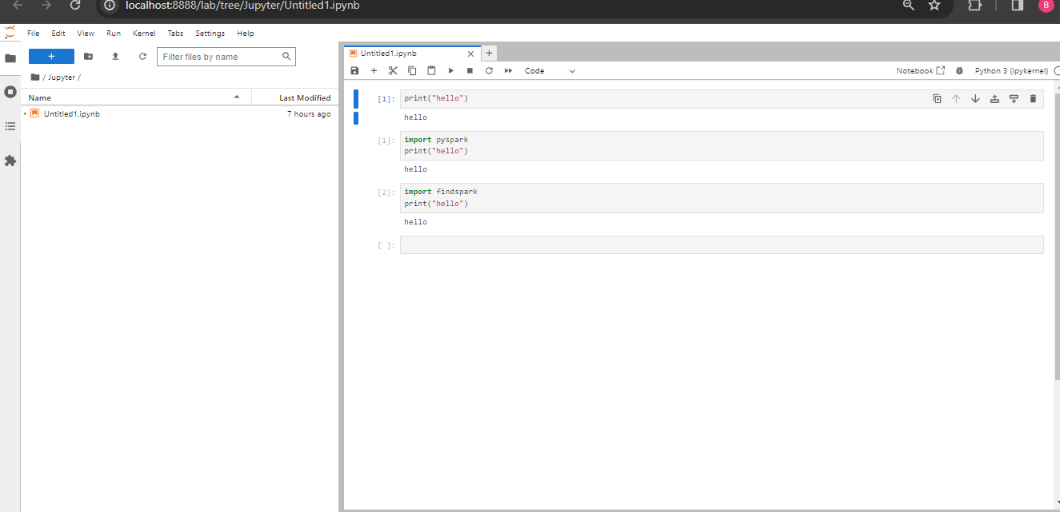**Jupyter lab webpage**

**Program on Jupyter-lab**

